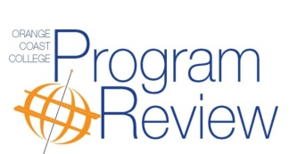

PROGRAM REVIEW PROCESS-INSTRUCTION

The purpose of the Comprehensive Program Review (CPR) is continuous program improvement. It is a self-study to provide a thorough, evidence-based analysis of departments/programs in order to understand their strengths, identify weaknesses and key areas of improvement, and create a workable plan for achieving the desired improvements. This also meets the Accrediting Commission for Community and Junior Colleges (ACCJC) requirements for all colleges in the western region.

This process is designed to:

- Provide a rigorous examination of the program and its courses, including their student learning outcomes
- Engage departments in planning program improvements that are responsive to student and community needs
- Provide information for resource allocation within departments and across the college

Every three years, all instructional programs will undergo a Comprehensive Program Review (CPR). Within the CPR, Annual Resource Requests (ARR) will be completed by all programs in resource areas: staffing, facilities, staff development, equipment and technology. The focus of the annual reviews will build upon resources needed to improve programs identified primarily in the comprehensive program review.

Through the CPR process, the following outcomes will be assured:

- Improving programs and services consistent with the College Mission, Academic Master Plan and the ISLOs for OCC.
- Determining program direction and goals for the next 3-5 years
- Fostering cooperation among college departments
- Developing information to assist in the allocation of resources
- Increasing responsiveness to student and community needs
- Improving response to external and demographic changes, including equity
- Responding to state and federal mandates for accountability

Prior to completion of the comprehensive program review, the drafted program review will undergo Peer Review. Peer Review is an objective review of the draft document by peer faculty members to ensure that the review is understood by the campus community and adequate justification and explanation is included for plans and resource requests (see Peer Review).

PROGRAM REVIEW AREAS

The comprehensive program review is comprised of THREE areas:

Program Relevancy
- Mission
- Status of plan/goals
- Program scope
- Curriculum
Program Effectiveness
- Enrollment & Access
- Success & Retention
- SLO Synthesis and Planning
- Resource need discussion
- Commendations
- Summary/closing
Planning
- Strategies
- Milestones for the next 3 years
- Resources needed if necessary + ARRs

PEER REVIEW
Orange Coast College established a peer review process to provide departments honest and objective observations to the first draft of the department’s comprehensive program review. It is an anonymous process. It is intended to maintain academic rigor and relevance and to foster integrity and innovation, as well as to provide the opportunity to increase awareness about other programs. Particular attention is paid to how effectively the program is meeting the needs of students, the college and the community:

- Overall quality of the program’s report
- Effectiveness of assessment activities in the program
- Analysis of the provided data
- Responses to any specific issues raised during the past three years
- Suggestions for plans/strategies the program/college might take to address weaknesses/challenges/opportunities/needs that have emerged from the analysis

One or more constituents outside of the program participate in the process and upon completion, the Office of Institutional Effectiveness uploads the peer review comments into each department’s document repository. The lead writer(s) reviews the comments, responsibly considers the peer review feedback, and makes any suggested changes.

PROCESS
- All first draft program reviews will undergo an anonymous peer review process.
- The faculty from the Instructional Planning Council and the Academic Senators will serve as peer reviewers.
- The peer reviewers will be assigned to various departments randomly, with the caveat they will not review their own department’s program review.
- All department leads/writers/members will assume all peer review comments are objective.
- Comments will be carefully read and considered.
- Questions regarding peer review suggestions or comments will go through the program review coordinator.
- Each department will have one and half to two weeks to incorporate the peer review feedback into their comprehensive program review or write a justification for not incorporating the feedback in order to complete the program review report.

LATE POLICY
A calendar is established and distributed to all lead writers and division deans for September-April of the CPR year. If the department lead believes he/she cannot meet the final deadlines, he/she should notify the program review coordinator and division dean to develop an alternate schedule. If the department lead cannot resolve the matter with the program review coordinator and division dean, he/she can ask for the vice president of instruction’s assistance.

Failure to complete the comprehensive program review reviews by the deadlines shall be treated accordingly:
- Resource Requests: The department may submit requests for resources, but their requests will be accompanied with the information that said department has not completed its most recent comprehensive program review. The department may include an explanation of the extenuating circumstances that prevented its timely completion of comprehensive program review on the resource request.
- Additional resource requests include the full-time faculty hiring request and the annual resource request. These resource requests will include the date of the last completed comprehensive program review.
- Other college committees may develop relevant policies on their own.
- Such departments will complete their program reviews within the following year.
This policy formalizes the best practice and accreditation standard that planning and resource allocations reflect decisions made on the basis of information, evidence, and demonstrated need.

AREAS OF ANNUAL REVIEW
The campus-wide program review model has 3 areas that undergo annual review the following 2 years of the 3-year cycle:
- The planning module will be accessed for milestone updates that may include new resource requests as well as new strategies
- Accessing the SLO module for continued course assessment and documentation
Accessing the AUO module for hybrid programs that need to complete any updates.

PROGRAM VIABILITY REVIEW PROCESS
The purpose of program review is continuous improvement of the program not a process for discontinuance as clearly stated in the Academic Senate for the California Community Colleges (ASCCC) program review white paper Program Review: Developing a Faculty Driven Process (1996, spring) and supported by our local program review guidelines. Programs in need of revitalization, as identified as a result of completing program review or other conditions, are forwarded and the college’s Viability Review Process (2016, spring) will be followed.

LINKAGE TO CAMPUS-WIDE PLANNING AND RESOURCE ALLOCATION
The comprehensive program review process culminates in planning strategies designed to enhance aspects of the program or student learning. The college’s planning cycle is explained below in the P-I-E chart. Program review occurs in Step 2 (planning phase). Program review results are integrated into college-wide planning in Step 3 during the three-year wing plan review and revision process. Certain plans will require resource allocation to ensure completion. Steps 4 - 5 integrate planning needs campus-wide and allow for each wing to prioritize its needs for College Council for the campus. Resource allocation for campus priorities are evaluated in Step 5 by the College Budget Committee and recommendations sent back to College Council for final approval. The P-I-E chart illustrates the college’s link between program review, planning and resource allocation. Program review links each program’s identified strategies to the current Education Master Plan (EMP).

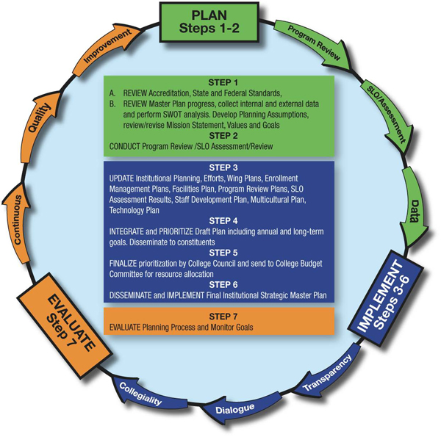

Midterm Program Review
The purpose of program review is continuous program improvement. All campus departments conduct a Comprehensive Program Review (CPR) every six years in order to review their role in achieving the college's mission, understand their program's strengths, identify key areas for improvement and create a workable plan for achieving the desired improvements and outcomes. The three-year strategic plans that result from this process are integrated into the appropriate wing plans, directly link to the Educational Master Plan, and are reviewed annually. CPR also produces department level plans that improve or enhance a department/program, but may not be explicitly linked to the master plan. The CPR process results in campus-wide planning driven by data analysis and guided by the college's goals for effective decision-making.
After three-years, all campus departments conduct a Midterm Program Review (MPR) that serves as a check-in point and for the department to assess their progress over the past three years. The MPR consists of an analysis of their most recent cycle of outcomes assessment (SLO/AUO/PSLO), department planning progress, external factors, and other relevant data. MPR leads to the revision of existing planning strategies for another three-year cycle or addition of new strategies. The program review processes are documented in the college's Program Review Guides. The ARR process allows for requests to be made based on assessment evidence that may occur outside of a program/department's program review cycle.
The approval process for the MPR included Institutional Effectiveness, Instructional Planning Council, Academic Senate, and College Council (November, 2018).
